Instructions for taking the career assessments on…
If you are having trouble accessing Career Cruising, please call 4184 or email blessing.richard@usd308.com.

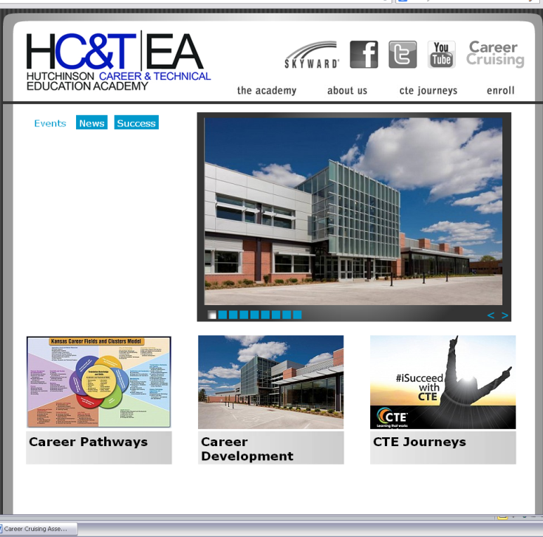

- Go to www.hutchctea.org

- Click on Career Cruising
http://www2.careercruising.com/default/cplogin/HUT

- Now, simply enter your school username
& password

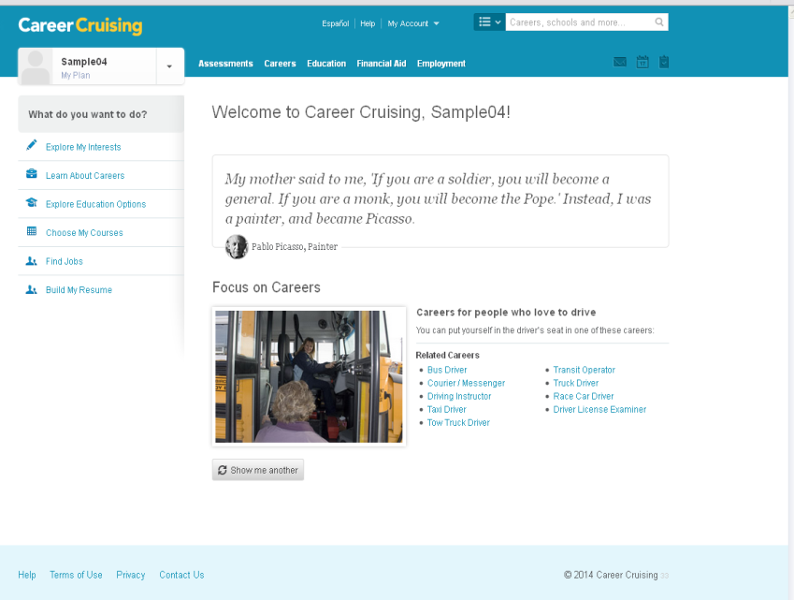

- Click into Explore My Interests.
You are now ready to complete the
Matchmaker & My Skills assessment
and the Learning Styles Inventory.

- Take your time, be honest, and when
you finish, have a conversation
with you Career Advisor about your
results!

